Practical - 9
Practical Title: Secure User Registration with Database Insert, Duplicate Email Check, and Password Hashing

Implement secure user registration by inserting user details into MySQL using MYSQLi. Validate input on frontend and backend, check duplicate email/username, hash passwords using password_hash(), and display appropriate messages.

Theory
1. Is password_hash() used before storing passwords?
- Yes, password_hash() is used in PHP before storing passwords.
- It converts plain-text passwords into secure hashes.
- The hashed password is stored in the MySQL database.
- During login, password_verify() checks the entered password.
2. Is duplicate email/username checked?
- Yes, duplicate email and student ID are checked before registration.
- A SELECT query checks whether the email or student ID already exists.
- If a duplicate is found, registration is rejected with an error message.
- UNIQUE constraints in MySQL provide additional protection against duplicates.
3. Are frontend and backend validations ?
- Frontend: JavaScript validates empty fields and checks email and password patterns.
- Backend: PHP checks that all required fields are filled in.
- PHP checks for duplicate email and student ID before inserting a new user.
- Prepared statements help prevent SQL injection, while password hashing protects stored passwords.
Implementation/Output/Result

My learning codes: https://drive.google.com/file/d/1CPP3uUq3gdKZxC3pFB7iheZVU7FCImSx/view?usp=drive_link

Evidence of Work (Screenshots)
Register page and Input Validation:
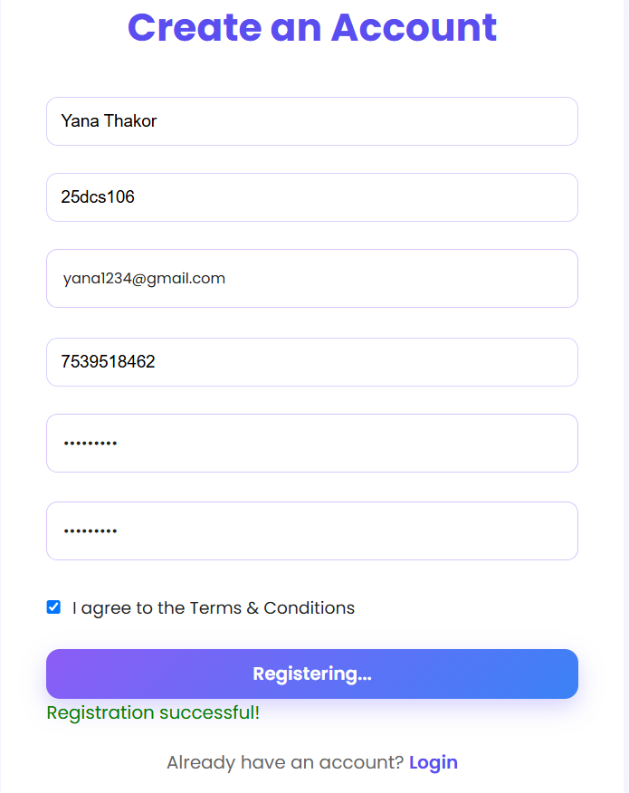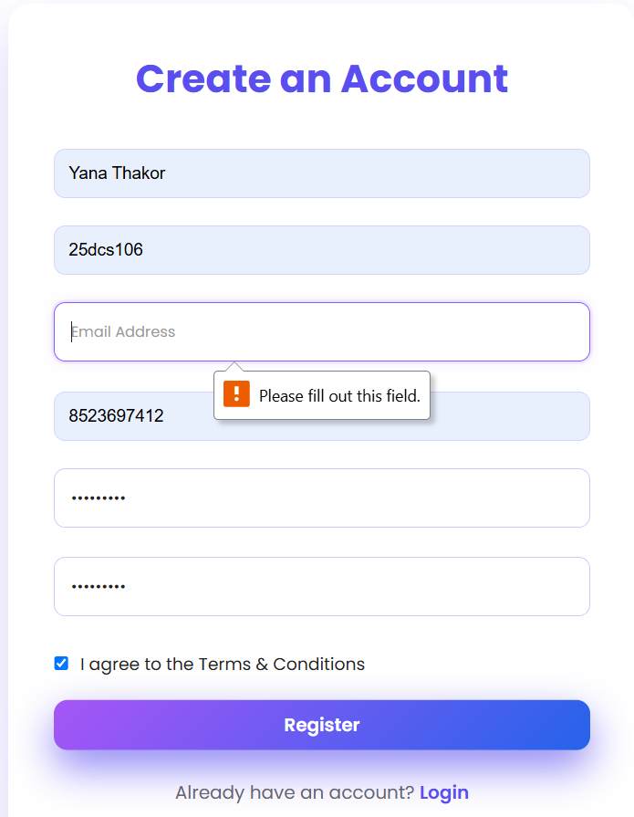
Registration and login successfully:
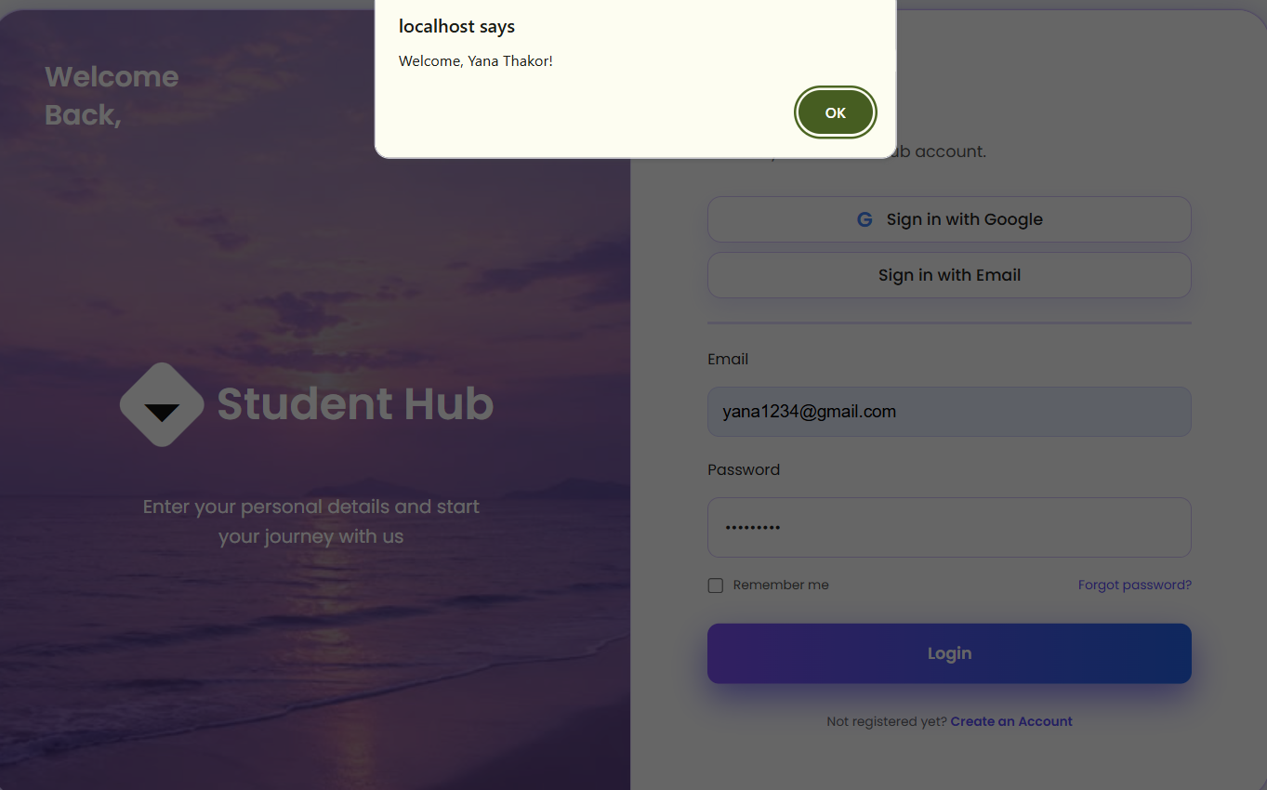

User details store in MySQL and Password hashing:
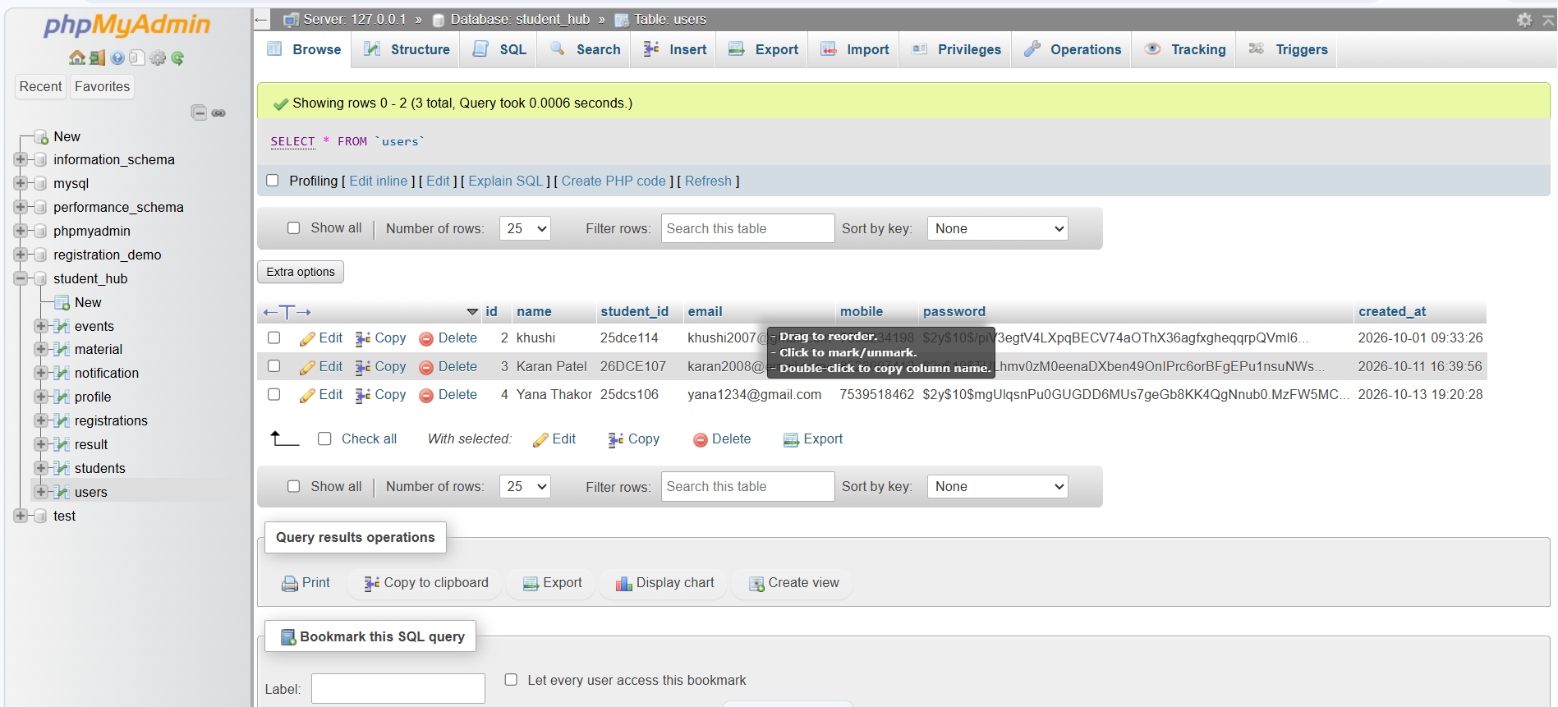
Duplicate Id or username:
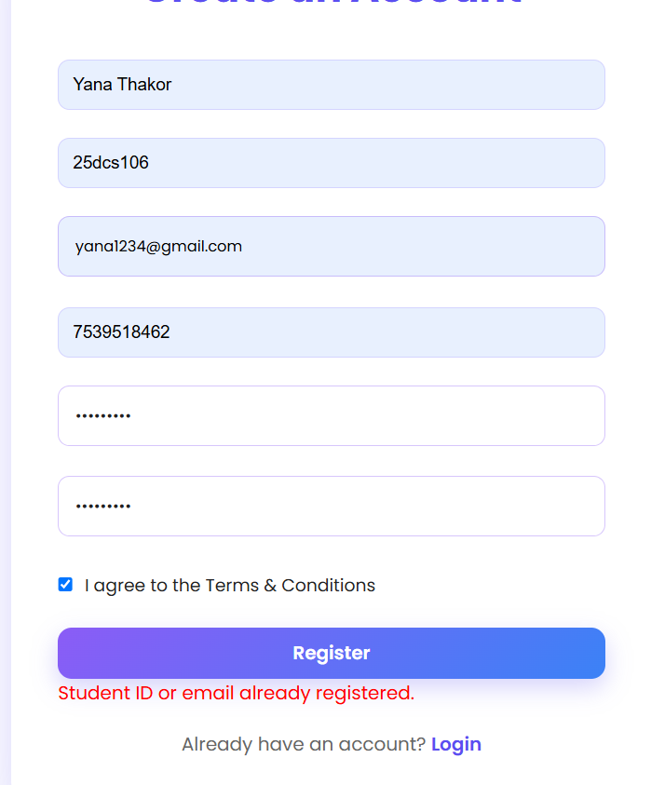

GitHub Repository Link:
Khushi-Thakor2007/Student-Hub-Portal

Challenges Faced:
- Handling frontend and backend validation and displaying appropriate error messages for invalid inputs.
- Preventing duplicate email/Student ID entries and securely storing passwords using password_hash().

Learning Outcomes:
- Learned to insert user details into MySQL using PHP MySQLi and prepared statements.
- Learned to validate user inputs, check duplicates, and securely hash passwords before storing them in the database.

Faculty Remarks:

